**Image and blurb for school website**

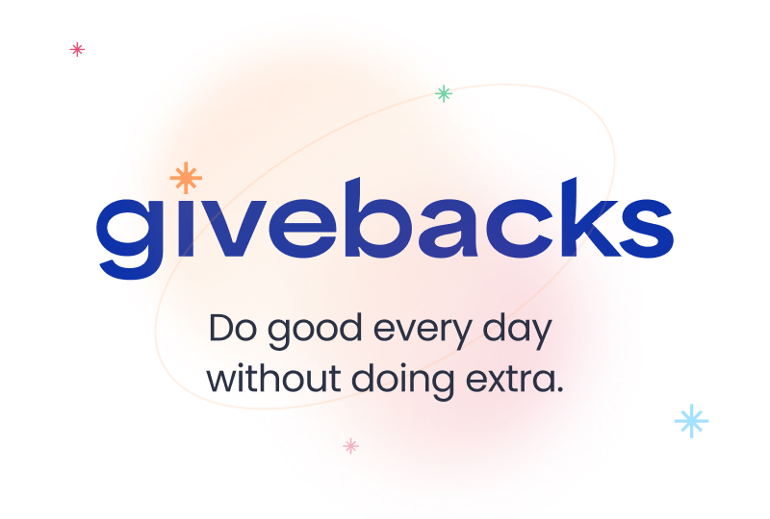

[Right click and save as picture to your desktop to use image on your website]

Join our Shop to Give program [add hyperlink to Givebacks with your unique signup link]

**Automatically power donations when you shop or dine—at no cost to you!**

When you sign up for our Shop to Give program through Givebacks, you’ll power donations to us every time you shop or dine at over 25,000 participating merchants.

Simply sign up, link your card for in-store offers, and add the desktop and mobile browser extensions for online offers. **Sign up here:** [add unique signup URL]